Related topics
Oscillation period, harmonic oscillation, mathematical pendulum, physical pendulum, variable g-pendulum, decomposition of force, gravitational force.

Principle
Earth’s gravitational acceleration g is determined for different lengths of the pendulum by means of the oscillating period. If the oscillating plane of the pendulum is not parallel to the gravitational field of the earth, only one component of the gravitational force acts on the pendulum movement.
Material
1 | Cobra4 Wireless Manager | 12600-00
1 | Cobra4 Wireless-Link | 12601-00
1 | Cobra4 Sensor-Unit Timer/Counter incl.1 × 12651-01 | 12651-00
1 | Movement sensor with cable | 12004-10
1 | Cobra4 Software – multiuser license | 14550-61
1 | Silk thread, l = 200 m | 02412-00
1 | Fish line, l = 20 m | 02089-00
1 | Wight holder, 1 g | 02407-00
2 | Pendulum ball with eyelet, d = 32 mm | 02466-01
1 | Tripod PHYWE | 02002-55
1 | Support rod PHYWE, l = 1000 mm | 02028-55
1 | Stand tube | 02060-00
1 | Plate holder, l = 0…10 mm | 02062-00
2 | Right angle clamp PHYWE | 02040-55
1 | Bench clamp PHYWE | 02010-00
1 | Semicircular scale with pointer | 08218-00
1 | Circular level | 02122-00
1 | Measuring tape, l = 2 m | 09936-00
1 | Pendulum for movement sensor | 12004-11
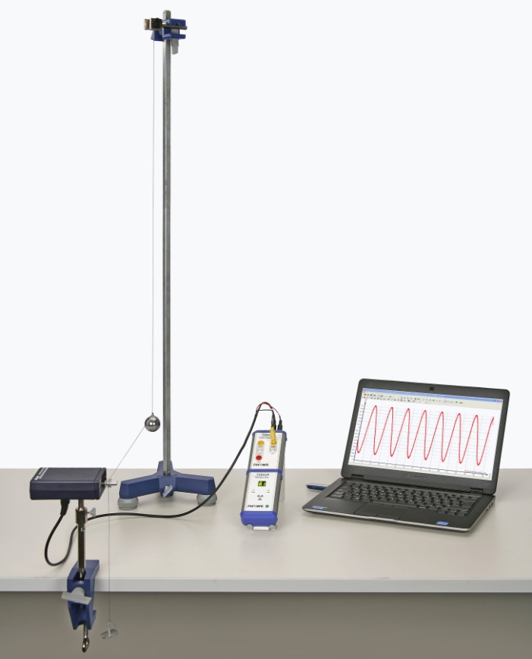
Fig. 1: Experimental setup.
 | Additionally required
1 | PC with USB-Interface, Windows XP or higher
Tasks
1. Determination of the oscillation period of a thread pendulum as a function of the pendulum length.
2. Determination of g.
3. Determination of the gravitational acceleration as a function of the inclination of the pendulum force.
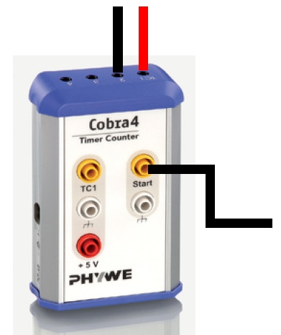
Fig. 2: Connection of the movement sensor to the Cobra4 Sensor Unit Timer Counter.
Set-up and procedure
In accordance with Fig. 1 measure the oscillation period of the thread pendulum.
Perform the electrical connection of the movement sensor to the Cobra4 Sensor unit Timer/Counter according to Fig. 2. The thread runs parallel and is placed across the larger of the two cord grooves on
the movement sensor.

Fig. 6 shows the set-up for measurement with the variable g pendulum.
Connect the Cobra4 Wireless Manager to the USB-interface of the computer and plug the Cobra4 Sensor-Unit Timer/Counter on the Cobra4 Wireless-Link and switch the link on. Start the “measure”-software and open the “Variable g pendulum” experiment. (“Experiment” “Open experiment”). All pre-settings that are necessary for measured value recording are now carried out except the axis diameter. To set this parameter double click on “Distance s1” and enter the right value (Fig. 3). The axis diameter in the ”Rotation” menu item is twice the distance from the pivot point of the pendulum to the attachment point of the silk thread that runs to the movement sensor. Set the pendulum in motion (small oscillation amplitude) and click on in the icon strip to start measurement.
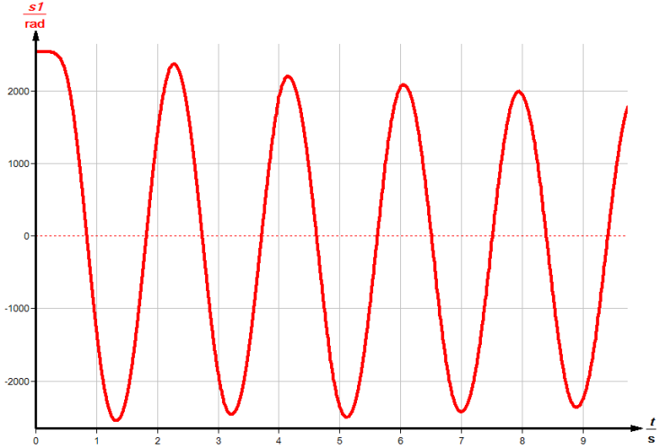
Fig. 4: Typical pendulum oscillation.
After approximately 5 oscillations click on the ”Stop measurement” icon. You receive a characteristic curve of the pendulum oscillation as shown in Fig. 4.
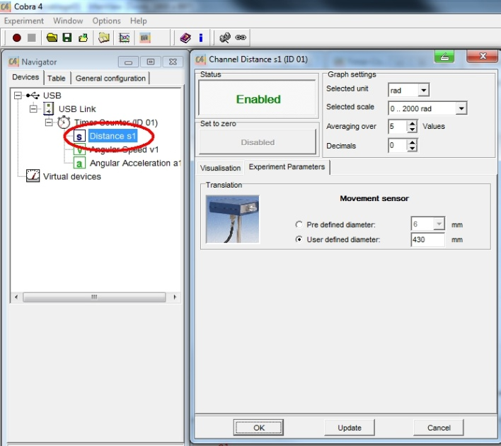
Fig. 3: Setting of the axle diameter.

Remark:
Move the 1 g weight holder, which tautens the coupling thread between the pendulum ball and the movement sensor, manually downward and then release it. This avoids lateral oscillations of the pendulum ball, which can lead to measurement errors.
Calculate the acceleration of gravity for various pendulum lengths, but constant pendulum mass.
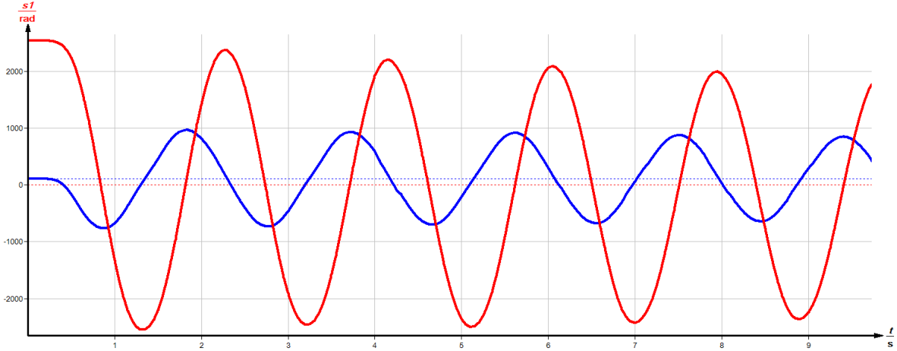
Fig. 5: Typical measurement result.
Subsequently, keep the pendulum length constant but increase the pendulum mass by hanging the second sphere onto the eyelet of the first one; and then determine g. Determine the period duration with the aid of the cursor lines, which can be freely moved and shifted onto the adjacent maxima or minima of the oscillation curve (Fig. 5).
Rebuild the experimental set-up according to Fig. 6. The oscillation plane is initially vertical. The round level located on top of the movement sensor housing facilitates the exact adjustment. Determine g for various deflection angles.
For identical initial deflection angles (e.g. approx. γ = 15°) determine g; in these measurements, however, the oscillation plane is not vertical but rather at an angle ϑ to the perpendicular. The following angles are recommended for measurement: ϑ = 0°, 10°, 20°, 40°, 60°, 80°.
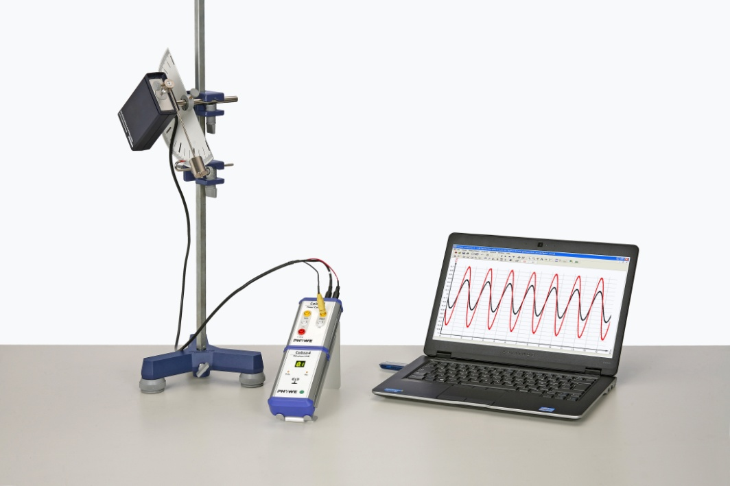
Fig. 6: Experimental set-up for the variable g-pendulum.

Theory and evaluation
As a good approximation, the pendulum used here can be treated as a mathematical (simple) pendulum having a length l. However, depending on the position of the pendulum weight, the length l deviates more or less from the geometric pendulum length L, which is measured between the pivot point and the centre of the moveable weight (compare Task 3). A retracting force acts on the pendulum mass m at a deflection equal to the angle ϑ

 | $$F\left(γ\right)=-mg∙\sin{γ≈-mgγ}$$ | for small angle $γ$

If one ensures that the amplitudes remain sufficiently small while experimenting, the movement can be described by the following differential equation:

$$l∙\frac{d^{2}γ}{dt^{2}}=-gγ$$

The following is obtained as the solution:

 | $$γ=γ_{0}∙\sin\left(\sqrt{\frac{g}{l}}∙t\right)$$ | (1)

This is a harmonic oscillation having the amplitude γ₀ and the oscillation period T.

 | $$T=2π\sqrt{\frac{l}{g}}$$ | (1)

If one rotates the oscillation plane around the angle ϑ with respect to the vertical plane, the components of the acceleration of gravity g(ϑ) which are effective in its oscillation plane are reduced to g(ϑ) = g・cosϑ and the following is obtained for the oscillation period:

 | $$T\left(ϑ\right)=2π\sqrt{\frac{l}{g∙\cos{ϑ}}}$$ | (2)

Table 1 contains exemplary measurements for different pendulum lengths; whereas the mass of the sphere is kept constant. An increase in the pendulum mass for constant pendulum lenghts supplies an identical acceleration of gravity value. In one sample measurement, the pendulum length is l = 0.9 m:

Number of spheres | g [m/s²]
1 | 9.75
2 | 9.76
l [m] |  |  | g [m/s²]
0.84 |  |  | 9.75
0.69 |  |  | 9.61
0.43 |  |  | 9.86
Table 1
The familiar equation (1) for the calculation of the period of a thread pendulum

$$T=2π∙\sqrt{\frac{l}{g}}$$

applies strictly only for the borderline case of infinitely small oscillation amplitudes. For greater amplitudes this equation must be replaced by an expression such as

$$T=2π\sqrt{\frac{l}{g}}\left(1+\frac{1}{4} \sin{²\frac{γ}{2}}+\frac{9}{64}\sin^{4}\frac{γ}{2}+…\right)$$

Thus, the oscillation period increases with increasing angle γ.
If

 | $$γ=\frac{4π²∙l}{T²}$$ | (3)

is used to calculate g, this results in an acceleration of gravity that becomes continually smaller. The measured values in Table 2 exhibit this exact behaviour. However, Table 2 also shows that angles smaller than 20° can be considered as being sufficiently small to satisfy the equation (3).

Maximal deflection [°] | g [m/s²]
5 | 9.87
10 | 9.82
20 | 9.82
45 | 8.67
90 | 7.07
approx. 180 | 3.95
Table 2

For a pendulum with vertical oscillation plane (Fig. 7), the tangential component of the weight mg sin γ is the restoring force of the oscillation. If the oscillation plane is at an angle ϑ to the perpendicular (Fig. 8), only the force component mg sin γ cos ϑ is effective. Therefore, for the oscillation period T it follows that

$$T=2π\sqrt{\frac{l}{g∙\cos{ϑ}}}$$

$ϑ$_{set} [°] | g [m/s²] | $ϑ$_{calculated} [°]
0 | 9.87 | 0
10 | 9.69 | 9.11
20 | 9.34 | 17.89
40 | 7.74 | 37.93
60 | 5.22 | 57.85
80 | 2.07 | 77.81
Table 3
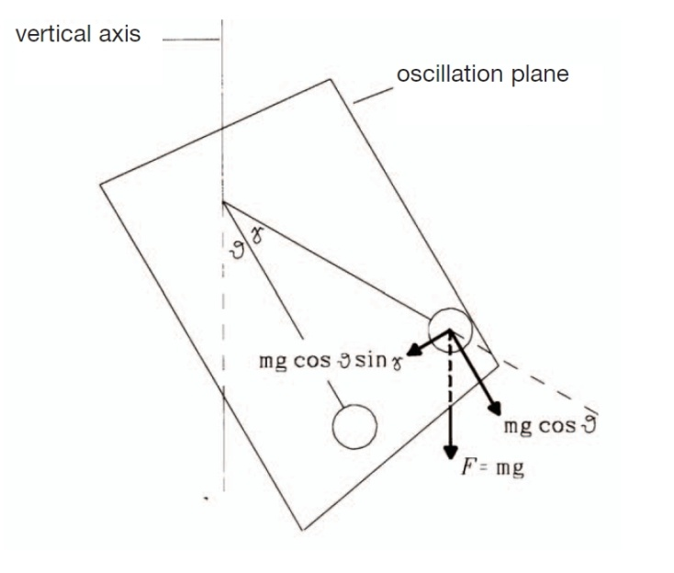
Fig. 8: Analysis of the force for a pendulum with an inclined oscillation plane (g pendulum).
In the framework provided by the measuring accuracy, the measurement data in Table 3 confirm this correlation.
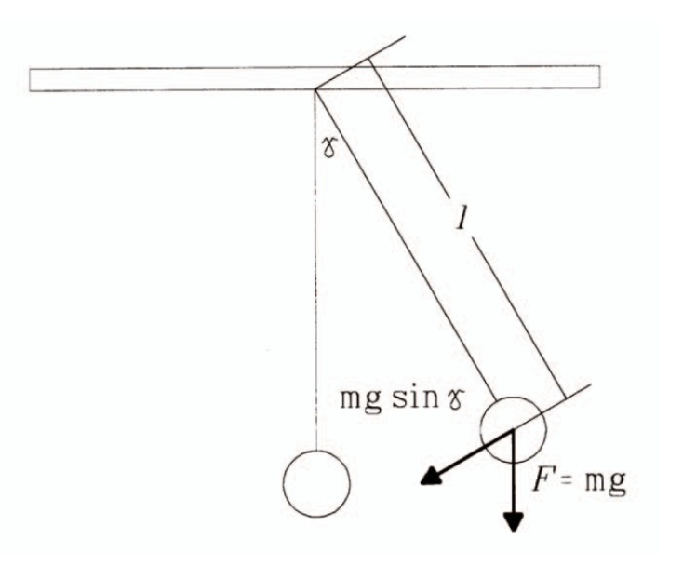
Fig. 7: Consideration of the standard pendulum.
Since with a variable g pendulum, the acceleration of gravity acting on the pendulum is virtually changeable, the experiment can also be performed in order to become an idea of how rapidly a vertical pendulum would oscillate on the moon or on Mars. On the moon the gravitational attraction is approximately 16.6% of that on the earth; this corresponds to an angle ϑ = 0.5°. The gravitational attraction on Mars can be simulated by an angular setting of ϑ = 69°, since the acceleration of gravity only reaches 38% of that on the earth.
In the evaluation of the oscillation periods the pendulum rod was considered massless. The pendulum length l was the distance of the centre of the supported mass from the centre of the rotational axis. If the mass of the pendulum rod is considered, this has the consequence that the centre of mass moves closer to the rotational axis, i.e. l becomes shorter. If an increase in measuring accuracy is desired, this effect must be taken into consideration.

Remarks
The weight hanging directly on the rotational axis of the movement sensor should not exceed 100 g and should also be only briefly attached to the movement sensor to avoid bearing damage.
In extremely short oscillation periods, signal transients or deformations can occur. These can be reduced if the sampling rate is changed. In any case, error-free recorded intervals can be selected from the measuring signal after completion of the measurements.
Sickle-shaped deformation of the oscillations are due to slippage of the thread across the cord groove on the movement sensor. This is avoided if the thread is wound around the cord groove once.
Since the movement recording is not performed without contact, slight damping of the measured oscillations does occur. In the calculation of alpha (t) differences of small sizes must be formed and divided by short time intervals. This results increased noise in the alpha (t) curve compared to the omega (t) curve. Angular velocities that are too small can no longer be registered by the movement sensor and are displayed as a reference line.
Instead of the movement sensor, the compact, fork-type light barrier (11207-20) can be used. However, in this case the experiment with the variable g pendulum cannot be performed.

